CHAPTER 5
PUBLIC FACILITIES, SERVICES AND UTILITIES

COMMUNITY CENTER

As the population of Lewisville increased, it became apparent that the log town hall built in 1884 had become inadequate, and construction of a new community center was begun. Originally it was believed the current, (1997), Community Hall was constructed by city authorities in 1906; however, there are records that indicate it was built by the LDS Church under the direction of David Kinghorn who was bishop of the Lewisville Ward, (May 1905 to June 1913). David Kinghorn’s history records the construction of the building in 1911.

The 3,999 square feet recreation hall measures 43 feet by 93 feet. A 216 square feet cloak room was added to the south side of the building and measures about 12 feet by 18 feet. The entire building measures 4,215 square feet. At one time, the building was used for roller skating, and the cloak room was used to store roller skates. The entrance to the building is on the east side of the cloak room. The building is constructed of randomly place, nonreinforced lava rock, taken from a quarry near Menan.

Warranty deed #37395 filed in the Jefferson County Courthouse records the sale of the property to the Lewisville Social Hall Stock Company (Limited) by John Walker, Chairman of the Board of Village Trustees, acting for the Village of Lewisville, on March 26, 1911 for $150.00. The deed contains a legal description of the property, but does not mention existing buildings.

On February 5, 1936, the property was sold to the Village of Lewisville by the LDS Church. Alfred Vernon Ball, the LDS Bishop at the time, (February 1933 to February 1943), signed the legal papers. Mayor Thomas Jackson, (1935 to 1939), recorded the sale of the property. The legal description of the property matches Warranty Deed #37395, but in addition includes all “tenements, hereditaments and appurtenances.” This deed is located in the Jefferson County Courthouse, Book 99, Page 199. The current, (1997), street address of the property is 117 East Main Street, Lewisville.

Page 5-1

ADDENDUM 1 -- DEED

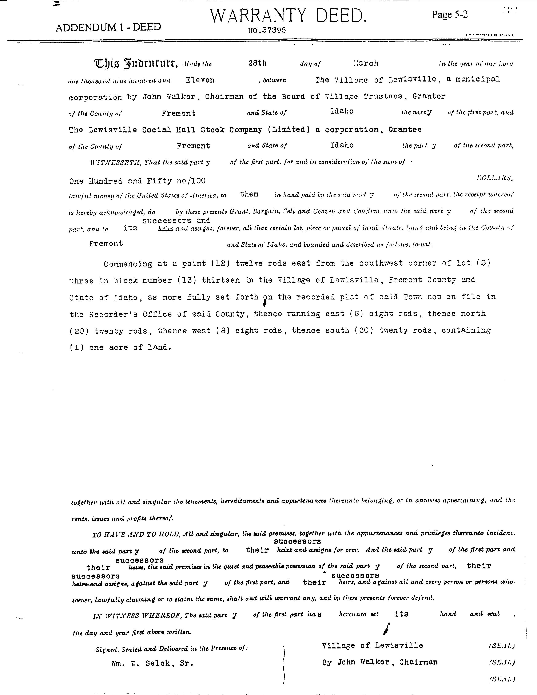
Page 5-2

ADDENDUM 2 -- DEED

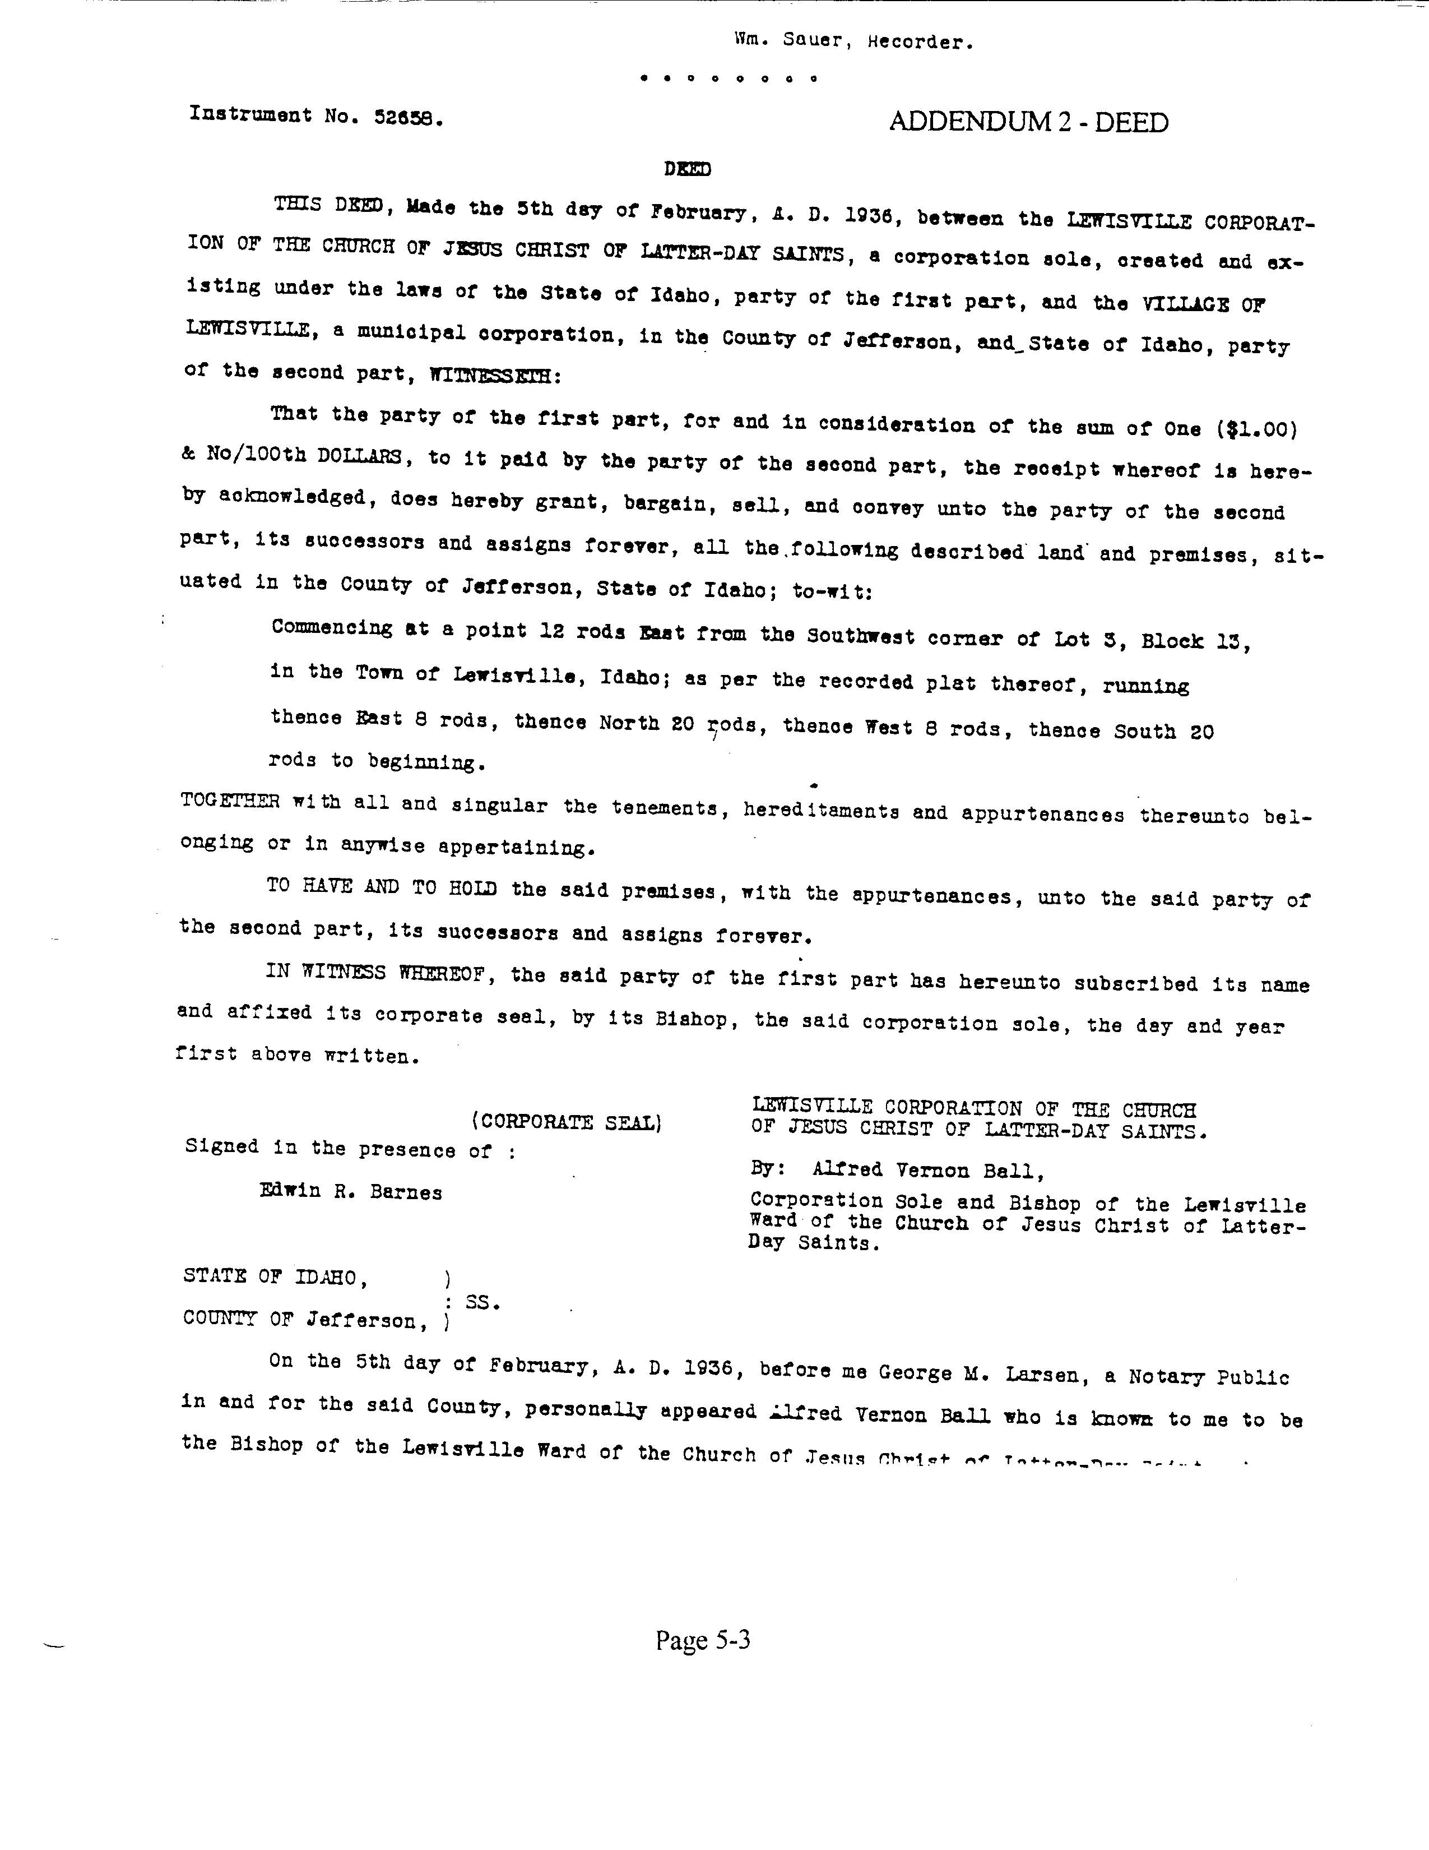
Page 5-3

Through the years, the Community Hall has been the site of many city, church and school activities. It continued to be used frequently, despite it’s severely deteriorated condition. Records for 1994 through 1997 suggest the building was used almost daily by ball teams, scout groups, dance classes, and early morning walkers. The only year with complete records available is 1995. Figure 5-1 compares 1995 usage by month. Table 5-1 shows the monthly building usage from 1994 through 1997. A comparison of the number of groups using the building for the same months shows similar use. The building was closed by the city council from April to December 1996. The building was reopened in January 1997 but was closed again in September, and it remained closed through 1998.

January 50
February 44
March 39
April 25
May 26
June 26
July 11
August 14
September 12
October 30
November 32
December 51

Page 5-4

Table 5-1 -- 1994 Through 1997 Community Hall Recreation Use
Month | 1994 | 1995 | 1996 | 1997
January | Not Available | 50 | 47 | 19
February | Not Available | 44 | 47 | 6
March | Not Available | 39 | 38 | 9
April | Not Available | 25 | Building Closed | 6
May | Not Available | 26 | Building Closed | Not Available
June | Not Available | 26 | Building Closed | Not Available
July | Not Available | 11 | Building Closed | Not Available
August | Not Available | 14 | Building Closed | Not Available
September | 1 | 12 | Building Closed | Building Closed
October | 28 | 30 | Building Closed | Building Closed
November | 47 | 32 | Building Closed | Building Closed
December | 55 | 51 | Building Closed | Building Closed

Page 5-5

A complete record of expenditures for repair and maintenance of the building is not available. However, five years of income and expenditure records are shown in Table 5-1. In the past, the LDS Church, the school district, and Lewisville City shared maintenance, utilities, and use of the building. Because city residents supported the cost of maintenance through property taxes, the hall was available for use by them at no cost. Minutes of city council meetings show the cost of nonresident rental of the hall varying from $8 to $40. Although the building was used almost daily, and rental fees were collected, the fees did not cover the expense of maintaining the building.

Table 5-2 -- 1992 Through 1996 Building Maintenance Expenditures
Year | Income | Expense  Utilities | Expense  Maintenance | Total  Income | Total  Expense
1992 | $283.00 | $1189.00 | None Recorded* | $283.00 | $1189.00
1993 | $678.00 | $1212.00 | None Recorded* | $678.00 | $1212.00
1994 | $628.00 | $1328.00 | $ 13.74* | $628.00 | $1341.74
1995 | $355.00 | $1074.00 | $220.11* | $355.00 | $2368.11
1996 | $ 46.00 | $1272.00 | $128.95 | $ 46.00 | $1400.95

* 1. None recorded -- There were indications in the minute book that money had been paid for some type of repair to buildings; but, the amount, kind of repair, and which facility was
repaired was not recorded.

* 2. It was noted in the minute book that a bill for $13.74 had been paid October 1994 to Becker, Inc. for the “hall floor”.

* 3. A payment for $220.11 in 1995 includes materials bought for the City Hall and Library as well as the Community Center.

Page 5-6

In January 1997, the council began considering the possibility of repairing the building, and it was reopened. The policy for managing the hall was revised. The 1997 rental for the building was $20 a month for those using the building on a regular basis. Rental for nonresidents using the building for specific occasions was $1 a person. The building was available for public use from 7 p.m. to 8 p.m. on weekdays and Saturday and Sunday, in addition to the time scheduled for monthly users. Keys were issued to persons over 18 years old, who were responsible for any damage to the building. Nine keys were issued to adult coaches of ball teams. The building was available for rent to dance classes, early morning walkers, or for other uses, but was only being rented by ball teams. Young adults and children were not allowed to use the building without adult supervision. In the fall of 1997, the building was again closed until an assessment could be made and the future of the building determined by the city council.

Originally the city council considered updating the building by adding a new restroom facility, repairing and refinishing the floor, updating electrical service, and painting both the interior and exterior. A committee was appointed by the city council to consider options and gather bids for the work. Before proceeding with the repairs, the council decided to have an engineer and architect inspect the building to determine its structural condition. That report was made by Winston R. Dyer of Forsgren Associates in Rexburg and was returned to the city council March 19, 1997. The engineer’s recommendation indicated the building had sustained considerable structural deterioration. The estimated cost of reinforcing the masonry to make the building structurally sound was estimated at about $100,000. In addition, other parts of the building would have to be brought to the standards of the Uniform Building Code adopted by Jefferson County. Since restoration of the building would be expensive, the engineer’s recommendation was that funds would be better used to construct a new building that would house the city offices, library, and community facilities.

Sources: Lewisville Centennial Book (Available at Lewisville City Library)
Jefferson County Courthouse, County Clerk’s Office
Jefferson County Courthouse, Assessor’s Office
Lewisville City, Minutes of City Council Meetings
Lewisville City, Records of Community Hall Rental

Page 5-7

ADDENDUM 3 -- ENGINEERING REVIEW, FORSGREN PERKINS

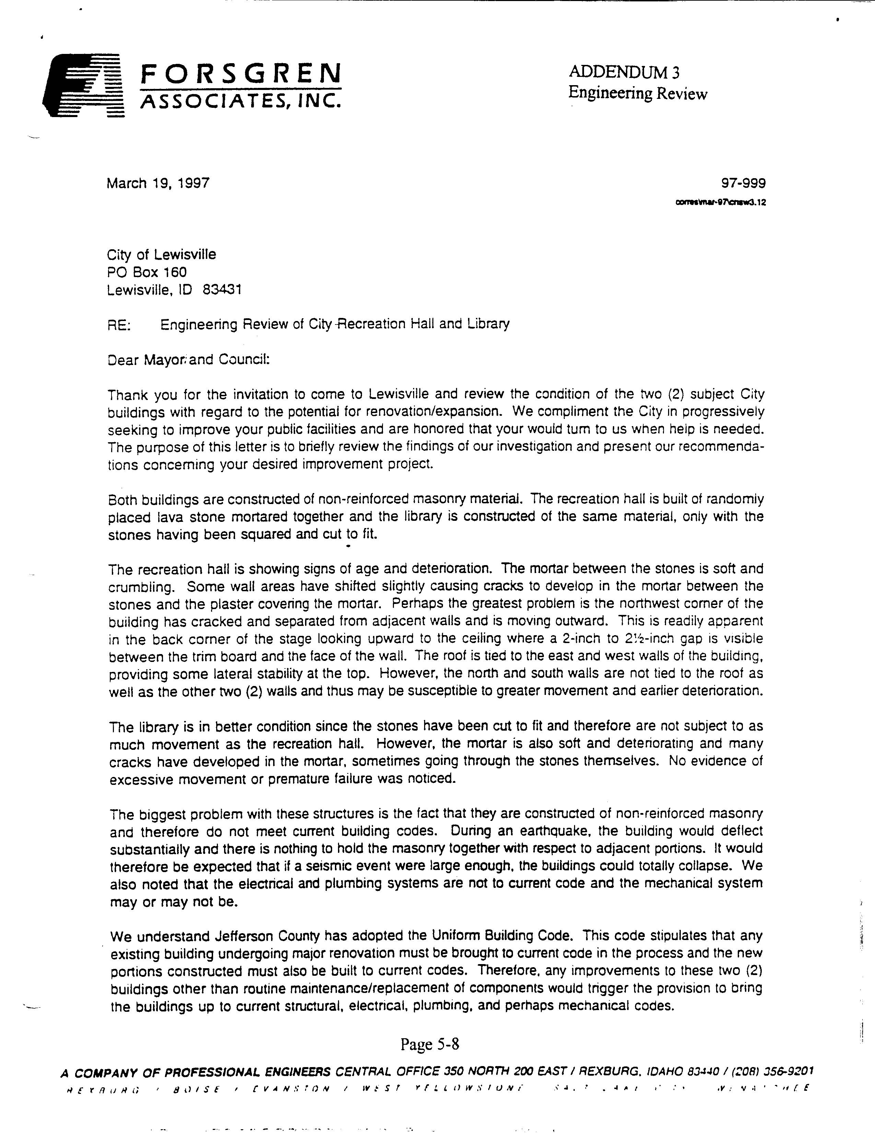
Page 5-8
ADDENDUM 3 -- ENGINEERING REVIEW, PAGE 2

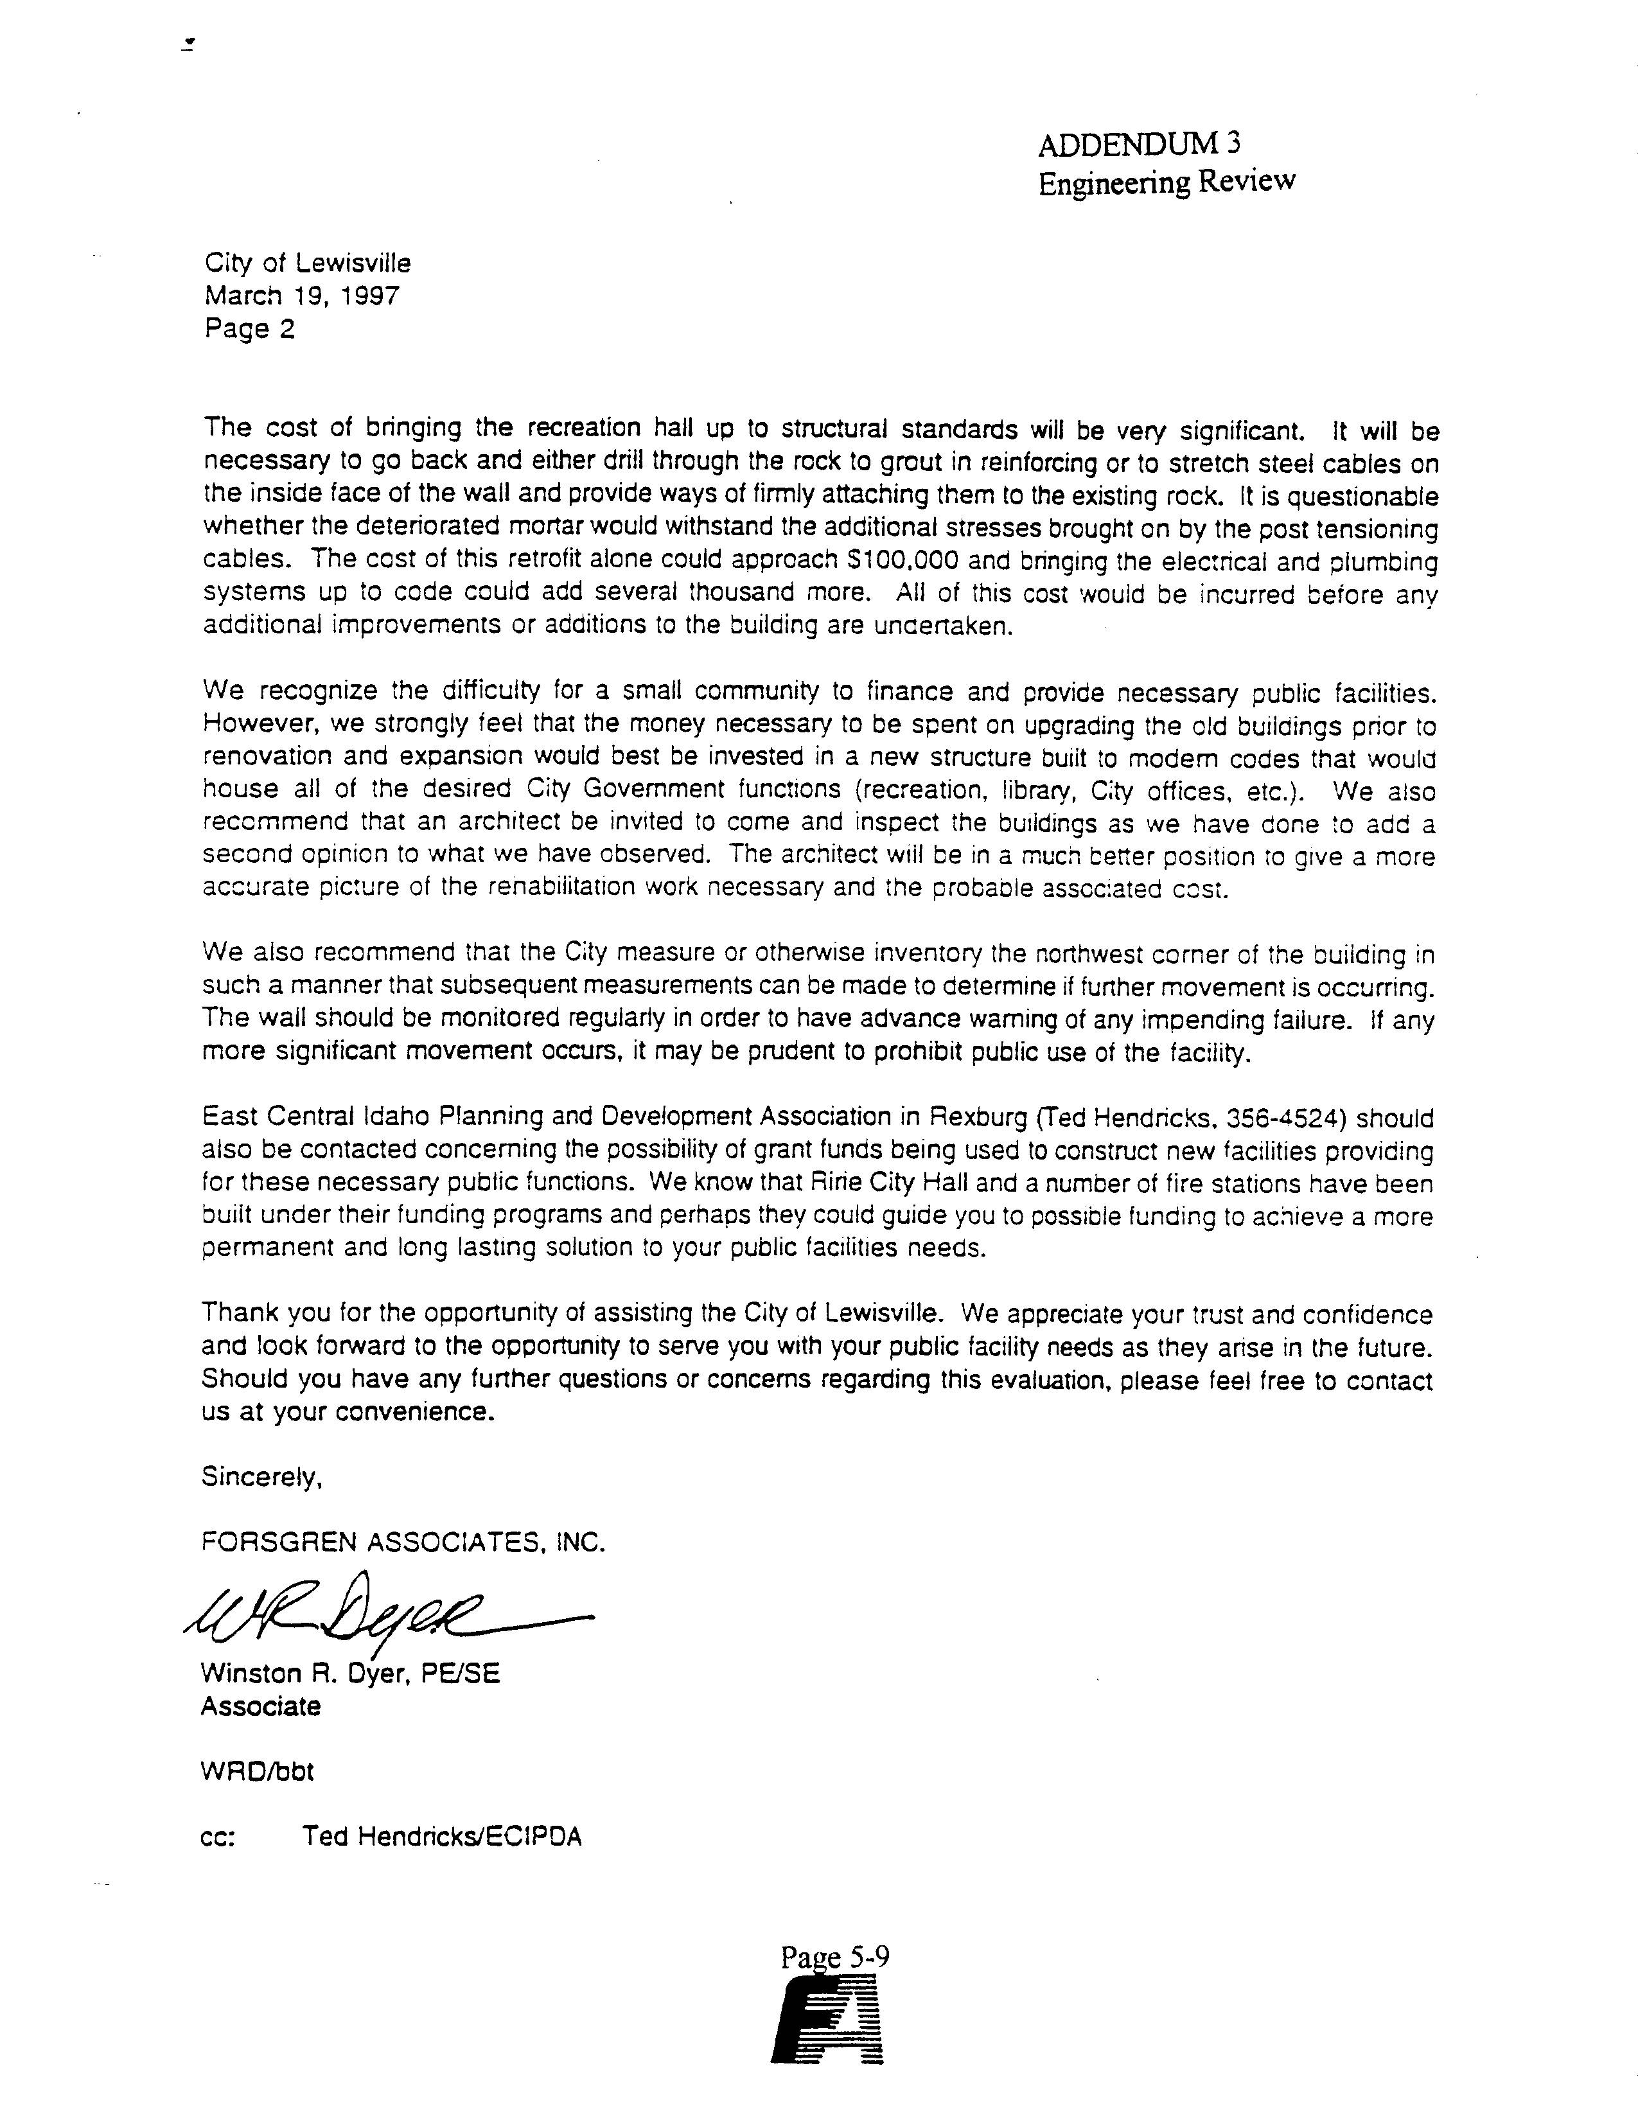

Page 5-9

CITY OFFICES AND JAIL

Eight years after the City of Lewisville had been incorporated, the city council authorized construction of a city office building, sheriff’s office, and jail. The 16 by 30 foot building, erected in 1912 by James T. Wilson, is located west of the community center at 115 East Main. It is constructed of black lava rocks quarried near Menan, and was completed at a cost of $1,019.88. Unlike the community center constructed of randomly placed stone, the rocks used in the city building were squared and cut to fit.

Through the years, this building has been remodeled to include plumbing, heating, and electrical service. A small addition was built on the north side to provide more space and cover the stairwell that originally allowed access to the pioneer-vintage jail cells in the basement. During the state’s centennial celebration, the basement room, which had been used for storage, was cleaned and the two jail cells restored somewhat to the original condition. Currently, (1997), one cell is used for storage of city and library records and equipment. The other remains as a jail cell with the original strap iron doors, wire cot, pot-bellied stove and chamber pot. The building, especially the jail, has become a source of interest, particularly for children and scout groups, and to tourists who have heard about it from local people. The building has significant historical potential, and may qualify as a local, state, or national historic site.

In 1962, the city established a public library in the building. City documents continue to be housed there; and, city council and library board meetings, local, state, and national elections, and other public meetings are held in the building. Parks and Lewisville Canal Company, Lion’s Club, and TOPS Club meetings are also held there. Space is extremely limited, and the office and storage needs of the city offices and library are barely met.

In 1997, before considering renovations to the building, the city council authorized an inspection of the structure by Forsgren Associates in Rexburg, Idaho. After inspecting the building, engineers determined the mortar between the lava rock has become soft and is deteriorating, causing cracks in the mortar and in the rock. Neither the basic structure of the building, nor the electrical, plumbing, or mechanical systems meet current building codes. The cracks in the foundation of the building also allow moisture to seep in, washing mortar, sand, and dirt onto the stairway leading to the basement. The engineer’s report recommended that, because of the expense involved in restoring the building to current codes, the city should consider consulting an architect for advice and probably construct a new building rather than restore the old one. The Forsgren report is included in Addendum 3, page 5-8.

Page 5-10

LIBRARY

The Lewisville Public Library began as the dream of a small girl in a second-grade classroom in Lewisville Elementary School in 1924. Lifelong Lewisville resident, Melba Williamson, had learned to read, but there were not enough books to satisfy the hunger for the beautiful words and ideas contained in books. Thirty years later, (1962), she was given permission by the city council to borrow books from Idaho State Library and house them in the city building. She began to build the library with a budget of $300 a year, donations, and volunteer help. Within a few years the collection had grown significantly, and a restroom, electricity, gas heating, and shelving made the library more functional and comfortable.

In the 1970's the city council appointed a library board. Mrs. Williamson became the library director, and a librarian was hired. Mrs. Williamson served as library director for 32 years, until her death in 1994. Following Mrs. Williamson, Faylene Christensen became the library director, and the city employed two part-time librarians. The library board and Mrs. Christensen began to qualify the library for grant programs sponsored by the state library and local benefactors. The library hours were extended to 12 hours a week, and a telephone was installed. Mrs. Christensen left the library in 1996, and Mary Jane Zimmermann became the library director. In September 1997, LaDawn Landon became library director.

During the 1996-1997 fiscal year, the library board completed a long-range plan, defining the library’s role in the community and setting goals for future growth. As a result of the plan, several administrative changes were made. The board enacted policies regarding the selection, maintenance and use of the library books, tapes, and reference collections. In the past, the library was able to be very casual and personal with regard to overdue books and check-out procedures. Because the population had grown in recent years, the library had many overdue books, and it was difficult to maintain patron records. For this reason, the board required library patrons to have a library card before taking books from the library, established fines for overdue books, and developed a method for updating patron information annually. In accordance with equal access and privacy laws, the board also required non-resident library card fees and developed a policy regarding censorship and intellectual freedom consistent with the American Library Association and Idaho State Library. Both the library’s long-range plan and collection development policy, as well as current budget information and annual reports, can be found on file at the library.

The annual library-use report submitted to the state for fiscal year 1995-1996 recorded 234 registered borrowers. Of those, 115 lived outside the city limits. The library was open 12 hours a week. The library director worked two hours a week, and the two librarians each worked 5 hours a week. The budget for that year was $3,695, a per capita expenditure of $5.47 per person. The total expenditure for the year was $4,410, a per capita expense of $6.53 per person.

Page 5-11

Table 5-3 -- Comparison of Library Borrowers, Fiscal Year 1995-1996
 | Lewisville | Ririe | Roberts
Population | 675 | 718 | 672
Total Registered Borrowers | 234 | 187 | 208
Non Resident Borrowers | 115 | 31 | 67
Percent of Non Resident Borrowers | 33% | 14% | 24%

Page 5-12

City Hours

Lewisville 12.5
Ririe 23.9
Roberts 14.7

Page 5-13
Table 5-4 -- FY 1995-1996 Comparison of Annual Library Hours and Use
 | Lewisville | Ririe | Roberts
Total Hours | 624 | 1196 | 734
Annual Attendance | Not Recorded | 3829 | 2047
Reference Requests | Not Recorded | 356 | 200
Children’s Programs | Not Recorded | 160 | 30

Page 5-14

City Income

Lewisville $3,695.00
Ririe $8,336.00
Roberts $6,063.00

Page 5-15
Table 5-5 -- FY 1995-1996 Comparison of Expenditures
 | Lewisville | Ririe | Roberts
Total Wages | $2,736.00 | $8,564.00 | $3,168.00
Director’s Wages | $ 546.00  2 hrs/wk | $3,744.00  12 hrs/wk | $2,652.00  12 hrs/wk
Collection | $ 869.00 | $1,100.00 | $1,610.00
Collection - Per Capita | $1.29 | $1.53 | $2.40
Capitol Improvements | $0.00 | $1,885.00 | $1,100.00
Total Expense | $4,410.00 | $11,439.00 | $6,155,00
Total Per Capita Expense | $6.53 | $15.93 | $9.16

Page 5-16
Additions to the library collection were not recorded for fiscal year 1995-1996. Because materials had not been weeded from the library for several years, an extensive housecleaning took place in the fall. A total of 2,530 various items were weeded from the collection. These included books, old magazines, broken tapes, records, and extremely outdated reference materials.

The total number of items in the collection was reported to be 3,006 and included fiction and nonfiction books, an encyclopedia set, music tapes for adults and children, books-on-tape for adults and children, several classic records, including classical recordings and well-known popular performers, some religious books, U.S. and Idaho history books, and a special collection that included Daughters of the Utah Pioneers historical material, a set of leather-bound History of the World, and a set of leather-bound early 1900 Idaho Code books.

Area of Interest Number

Adult 1,508
Young Adult 631
Children 733
Reference 69
Audio 144
Video 8

Page 5-17

Format Number

Books 2941
Audio Tapes 144
Video Tapes 8
Periodicals 0
Computer 0

In January 1997 patrons were required to have a library card, renewable annually, to check out library materials. The total number of registered borrowers at the end of the third quarter of the 1996-1997 fiscal year was 187. Resident borrowers totaled 143, an 83 percent increase from the 119 borrowers reported in 1995-1996 fiscal year. The reported number of nonresident borrowers was 44, a 62 percent decrease from the previous year. The library budget increased to $4,000 for the 1996-1997 fiscal year. Library hours, the number of staff, and staff hours remained the same as the previous year. At the end of the third quarter of the year, the library had 1,097 people using the library; and, 912 books, eight videos, and three tapes checked out. The total number of materials added to and weeded from the collection was not available at the time this report was written. The library also applied for and received grants for books from Idaho Community Foundation and for a computer, software, and Internet service from Idaho State Library.

During 1997, the library offered a story hour once a week with an average attendance of seven children of various ages. There were 15 children enrolled in the summer reading program. All but one completed the program. Funds were donated to provide books, materials, treats and prizes for the children, and the average weekly attendance was about 15 children. Three special activities were held during the year. A Halloween party was held in the fall, an egg hunt at the park in the spring, and a children’s parade in July. These events were very well attended with over 20 children participating.

Page 5-18

With the exception of some repair and painting on the exterior of the building, no capitol expenditures have been made for a few years. The library board had planned to paint the interior of the library during the summer of 1997, but, after the Forsgren report on the building, decided to postpone any further repairs or improvements until decisions about the future of the building were made.

Sources: Memoirs of Melba Williamson
Lewisville Public Library Annual Statistical Report, FY 1995-1996
Idaho Public Library Statistical Report, FY 1995-1996
Forsgren Associates Engineering Review, March, 1997

Page 5-19
SHOP

On July 7, 1988, the city bought .25 acre of ground located at the corner of First North and Adams Streets from Thomas and Gale Clement. A 150 foot by 110 foot building on the property is used as a shop where city trucks, tractors, and lawnmowers, as well as other equipment, is stored. A well was drilled on the property in 1896, and .04 inch of water rights was included with the sale of the property to the city. The water rights are recorded with the Department of Environmental Quality, #A25-11197. The deeds for the property are filed at Jefferson County Courthouse, #248962, and at the Lewisville City Offices.

CENTRAL FIRE DISTRICT STATION #3 PROPERTY

In April, 1988, the city agreed to lease the property between the city offices and the Community Hall to Jefferson Central Fire District, now Central Fire District, for a term of 99 years. The fire district agreed to pay the city $1.00 a year for the lease. The fire district constructed Central Fire Station #3 at that location. The city continues to own the property the building sits on, but the fire district owns the building. A well was dug at the direction of the fire district to provide the building with water. Since it is not necessary to register small domestic wells, there is not a record of the water rights.

PROPERTY SURROUNDING CITY BUILDINGS

The city owns the vacant property located directly north of the city offices and community center. Currently, (1997), the access to the property is through a driveway on the northwest corner, or through the city offices or community center grounds. Deeds for the property are located at the Jefferson County Courthouse or at the city offices.

Page 5-20

ADDENDUM 3 -- CENTRAL FIRE DISTRICT LEASE AGREEMENT

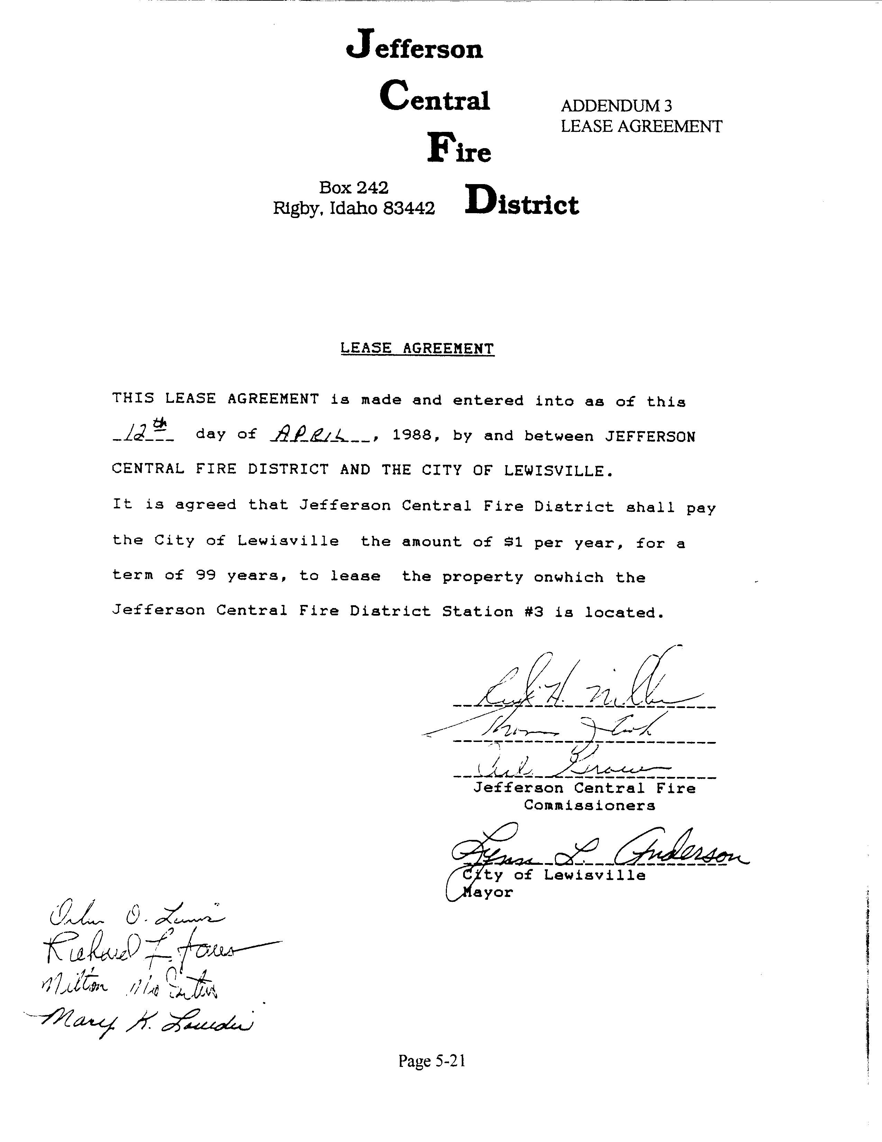
Page 5-21

ADDENDUM 4 -- LEWISVILLE CITY MAP, BLOCK 13
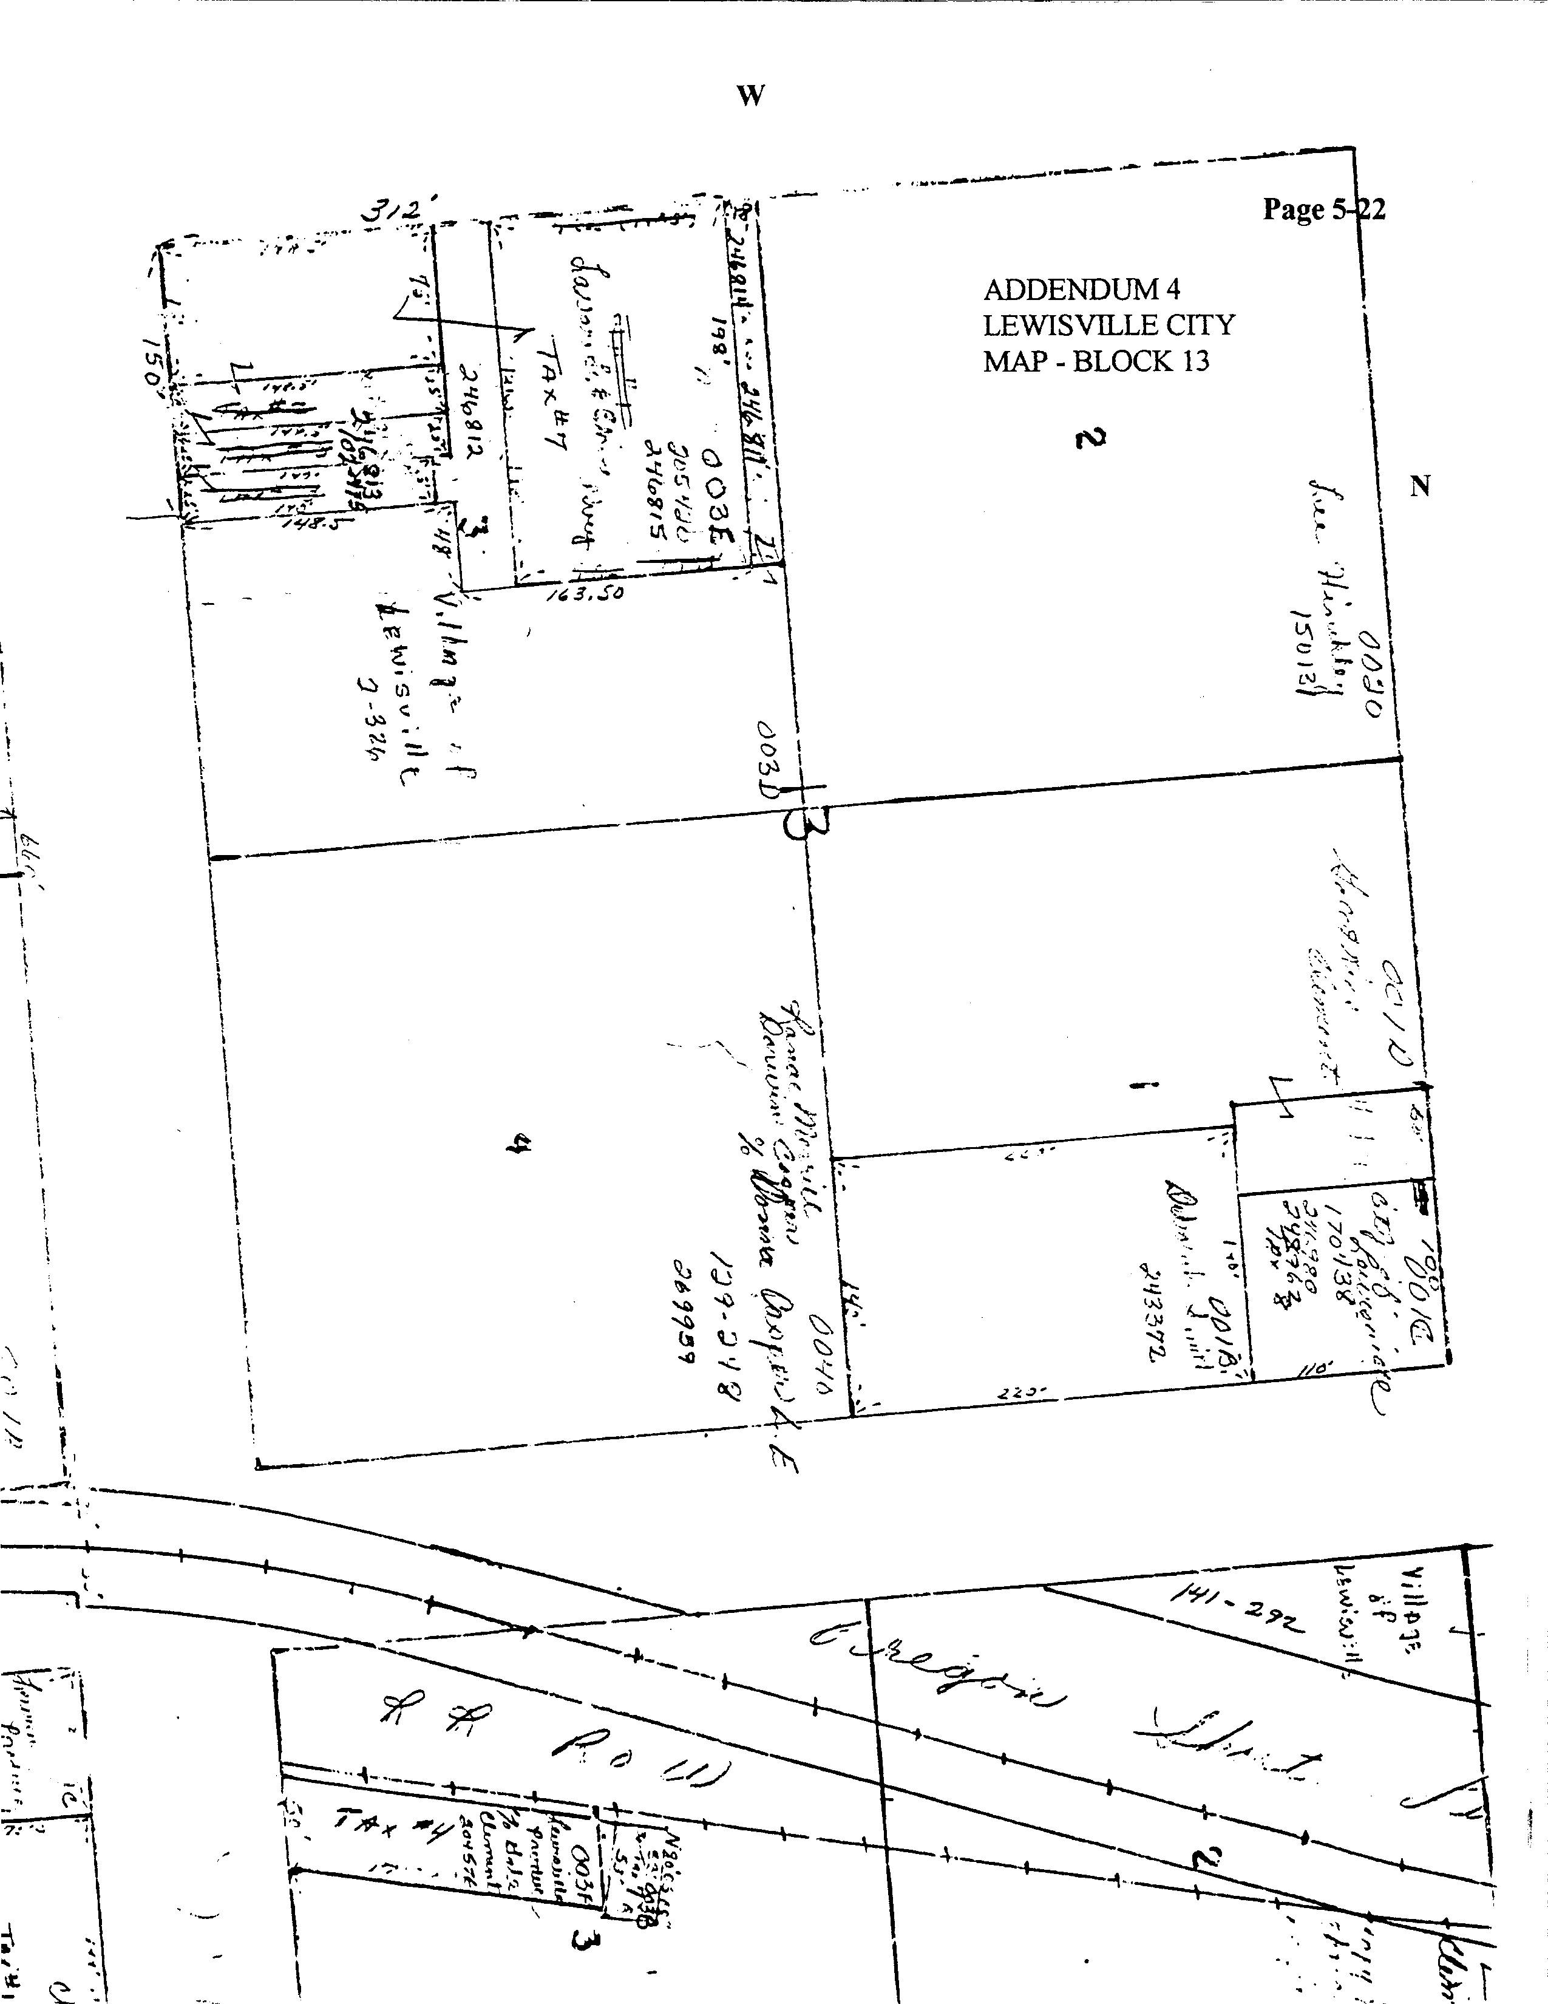
Page 5-22

LANDFILL

In 1959, the Bureau of Land Management deeded to the Village of Lewisville, 40 acres located southwest of the city to be used for a landfill. Minutes of a city council meeting dated August 18, 1992, record that the Environmental Protection Agency instructed the city council to cover the landfill, and the council complied. The area has not been used for a landfill since that time. Currently, (1997), the city is in the process of appraising the property for sale.

PARKS

The city owns a small, triangular piece of ground on the northwest corner of Block 14 adjacent to the railroad tracks. Grass has been planted there to create a green space, but the area is not big enough to accommodate playground equipment or picnic facilities. Deed #248962 on file at Jefferson County Courthouse and at the city offices contains a legal description of the sale and the property. A new well was drilled on the south tip of Jardine Park to provide irrigation water.

LEWISVILLE CEMETERY

With the death of Harriet Cordelia Bassett Hill in October of 1884, the settlers of Lewisville found themselves in need of a cemetery. Richard F. Jardine and William A. Walker selected the location of the Lewisville Cemetery; and, Brigham Ellsworth dedicated the site. In December, 1905, Howard W. Rokes, who owned the property, agreed to sell the land to the city for use as a cemetery. Currently, (1997), the cemetery is part of the Lewisville Cemetery District. Originally, the cemetery comprised about two acres of land. There are only a few plots left, and the district is negotiating to buy an additional five acres.

In 1997, there were about 500 headstones, several dating to the late 1800's. Many early settlers are buried in the cemetery including two of the daughters of early Mormon church leader, Brigham Young. Two Civil War veterans and several World War II, Korean War, and Viet Nam veterans are also buried there. Many of the graves and the occupants have interesting histories. Among those is the grave of a young man murdered in the early 1900's. Nearby is the grave of the person convicted and executed for the murder. The cemetery is rich in historical information and background, and may qualify as a local or state historical site.

Page 5-23

RECREATION

ACTIVITIES

Other than activities sponsored by Lewisville Public Library, there are no recreation programs organized by Lewisville City. Christmas programs, Easter egg hunts, summer fairs, Founder’s Day celebrations, and youth sports are sponsored by neighboring communities, and are attended by Lewisville residents. In the past, the Community Hall was available for use; however, the building was closed in the fall of 1997.

PARKS

The city is developing Jardine Park, a small park located on Adams Street. The LDS Church owns a park south of the city buildings which is frequently used by city residents. The park is available for use by reservation; but, it cannot be used on Sunday and is subject to standards set by the LDS Church.

TRAILS, CAMPING, FISHING, SKIING, AND RECREATION AREAS

There are no trails, camping, or recreation areas within the city. However, there are several state and national recreation sites within a reasonably short distance from the city. Yellowstone National Park, Grand Teton National Park, Harriman State Park, Jackson, Sun Valley, and several other ski resorts, as well as other state and national recreational areas are within four hours travel, and provide both summer and winter recreation.

Page 5-24

UTILITIES

Utilities within Lewisville City are provided by various businesses. The city currently, (1997), provides no utilities to city residences. The following services are available:

TELEPHONE SERVICE

Telephone service is available throughout the city. Lines are maintained and serviced by U.S. West. At present, there are no plans to expand services in Lewisville City.

ELECTRICITY

Electric service in the city is provided by Utah Power. There are no plans to expand or extend electric utilities in Lewisville in the near future.

NATURAL GAS

Natural gas lines enter the city from Highway 48, (3500 East), down First South Street to the railroad tracks where a regulator station is located. From there, the lines continue along First South and across the president streets. Second North and Second South are the only streets that do not have gas lines. All the homes within the city can be serviced. Extention of gas lines is anticipated as residential growth continues.

WASTE DISPOSAL

Waste disposal is contracted by individuals with private waste removal companies.

Page 5-25

WATER

The city owns five inches of water through the Parks and Lewisville Canal Company. The water has traditionally been turned into the ditches for city residents to use for watering yards. Domestic water is provided by private wells.

COMMUNICATIONS

Radio and television are available throughout the city. Cable television is provided by Teton Wireless through subscription. Many residents also subscribe to Internet and other technological services through various carriers.

RAILROAD

The Eastern Idaho Railroad owns a right-of-way along Adams Street. The small spur services potato processing plants and other businesses along the route. Rehabilitation of the ties along the track spurs was done in 1998. No further growth is projected; however, the railroad will consider expansion if there is interest in the area.

Page 5-26

